# AUTO CDC APIs

* Here, we will talk about AUTO CDC APIs. We will understand what auto CDC API are and how to use them in both SQL and Python syntax.
* Lake flow declarative pipelines simplify CDC processing with the Auto CDC APIs. Previously, we used the merge into statement for processing CDC feed and applying a **SCD type2** updates.
* However, merge into require complex logic to handle out-of-sequence records, otherwise it can produce incorrect results. With auto CDC APIs, Out-of-sequence records are automatically handled which ensure correct processing without the need to write hundreds of lines of code.
* In addition, Auto CDC natively supports updating tables using SCD type1 & type 2.



* Here we see the SQL syntax of Auto CDC.
  + - You start by creating a flow as **Auto CDC into a streaming table**.
    - This is the **target_table** into which the changes will be applied from CDC feed table specified as a streaming source.
    - **Keys** where you identify the primary key fields. If the key exists in the target table, the record will be updated. If not, it will be inserted.
    - Optionally with **apply as delete when condition**, you can specify that records where the **operation_type** field is DELETE should be deleted.
    - Next **sequence by** where you specify the sequence field for ordering how operations should be applied.
    - Then **columns** where you indicate the list of fields that should be added into the target table, and you can add the **EXCEPT** keyword to specify columns to ignore.
    - Lastly, you can decide **how to store the changes as SCD**, Type 1 or 2. Type 1 is the default.
    - **Note:** here that the target streaming table need to be already created before executing this command.

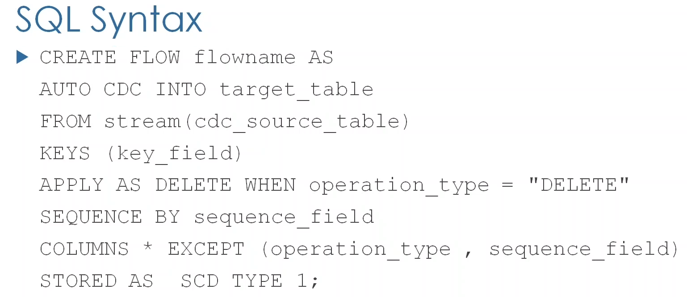

* The **sequence by** columns specifies the logical order of CDC events in the source table.
  + LDP uses the sequencing keys to automatically handle out of order records.
  + In fact, when you declare the target table, LDP creates two objects to manage CDC processing under the hood.
    - * A view with the same name as the **target** table, this target view presents the latest clean state of the data and
      * An internal target table with a prefix “**_apply_changes_storage**”. The internal table keeps track of the **change events**, along with extra information to correctly handle out of order data. These include **tombstone markers** to flag deleted rows, meaning to soft delete them until late arriving sequences are processed.
  + If multiple sequencing keys are needed, use a struct expression, these will order by the **first struct field** first, then by the second field if there is a tie. For example, when updates occur with the same timestamp.

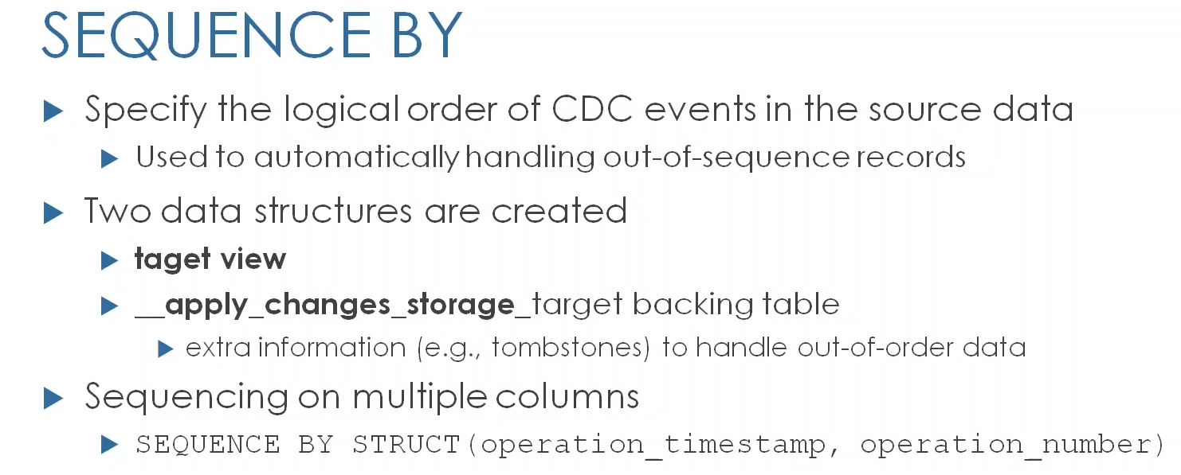

* Similarly, **Auto CDC APIs can be applied in Python syntax** using the **create_auto_CDC_flow** function.

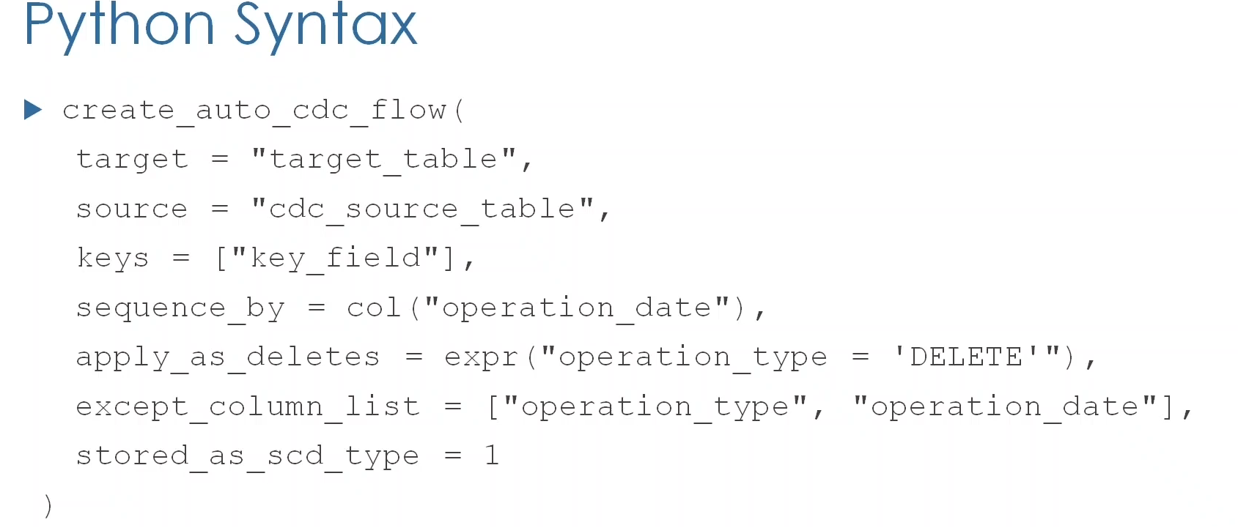

* CDC processing was also supported in the **old DLT framework** using the Apply changes syntax. It was supported in both SQL and Python.
  + - Apply changes is still supported for backward compatibility and you may encounter a question about it in the current exam version.
    - However, Databricks now recommend using the new Auto CDC API.

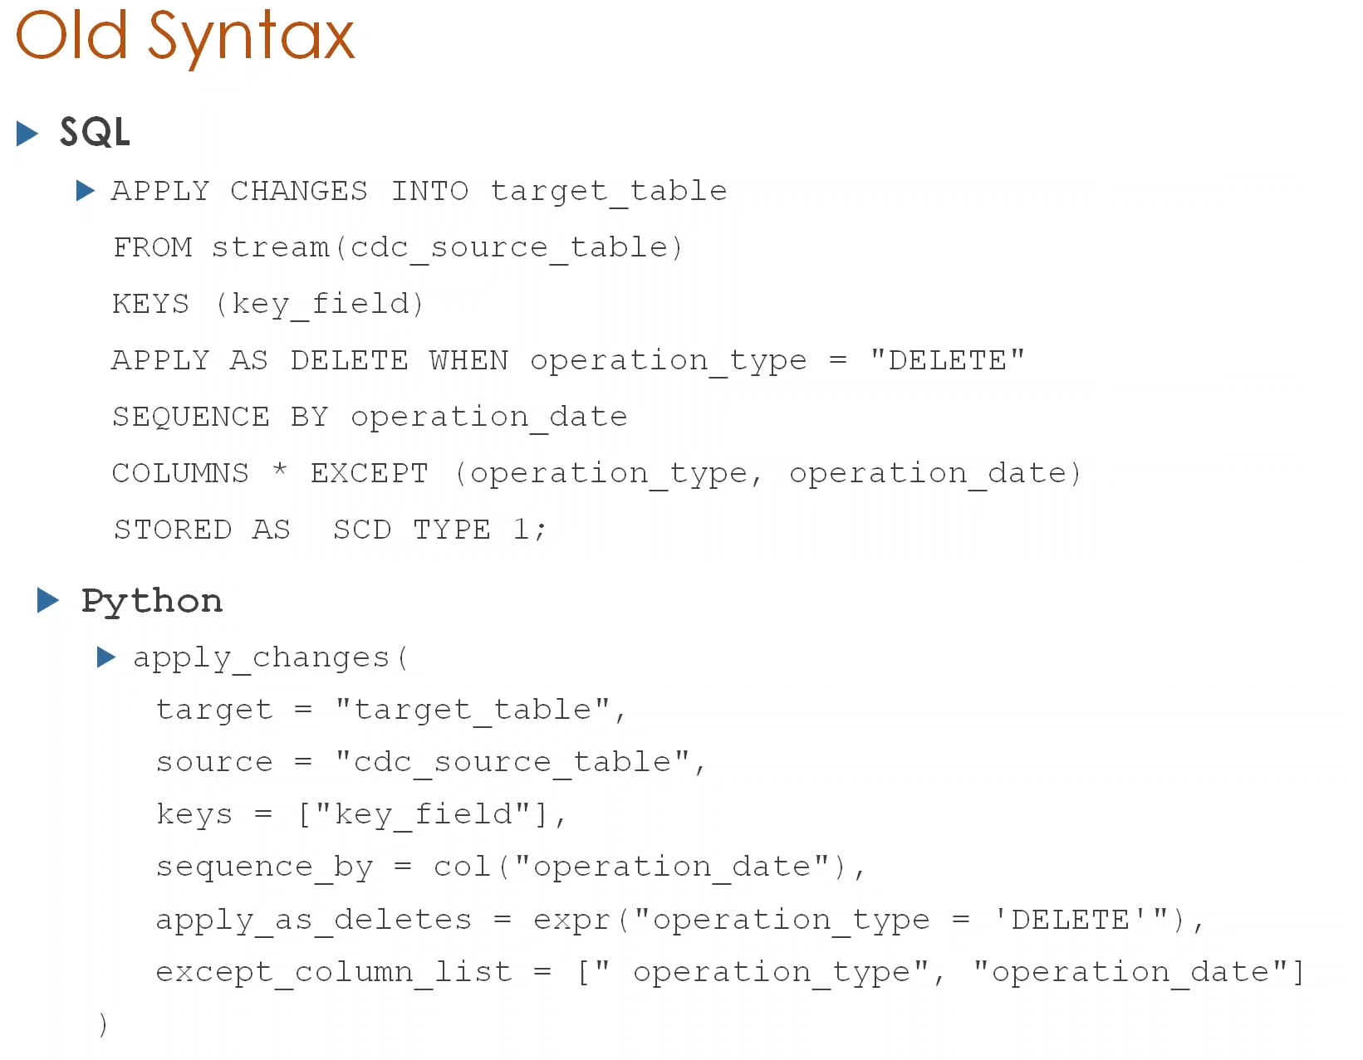

# AUTO CDC APIs (Hands On)

* Here, we will continue building our bookstore pipeline using lake flow declarative pipelines.
* We are going to use Auto CDC APIs to process our CDC customers data,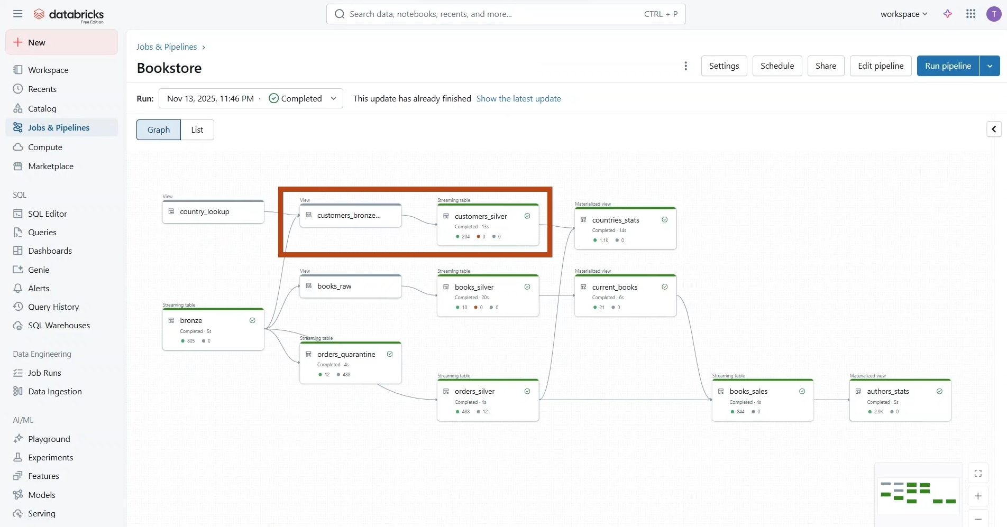

And apply a SCD type 2 updates to our **books** data.

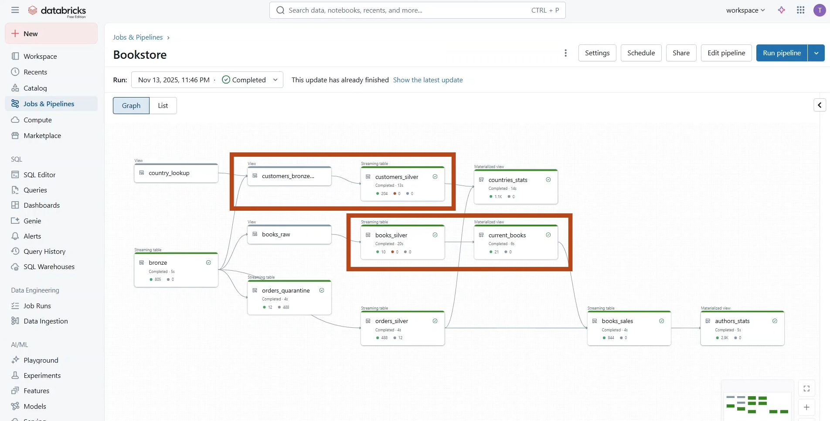

* In addition, we will use materialized views to create our gold layer objects.

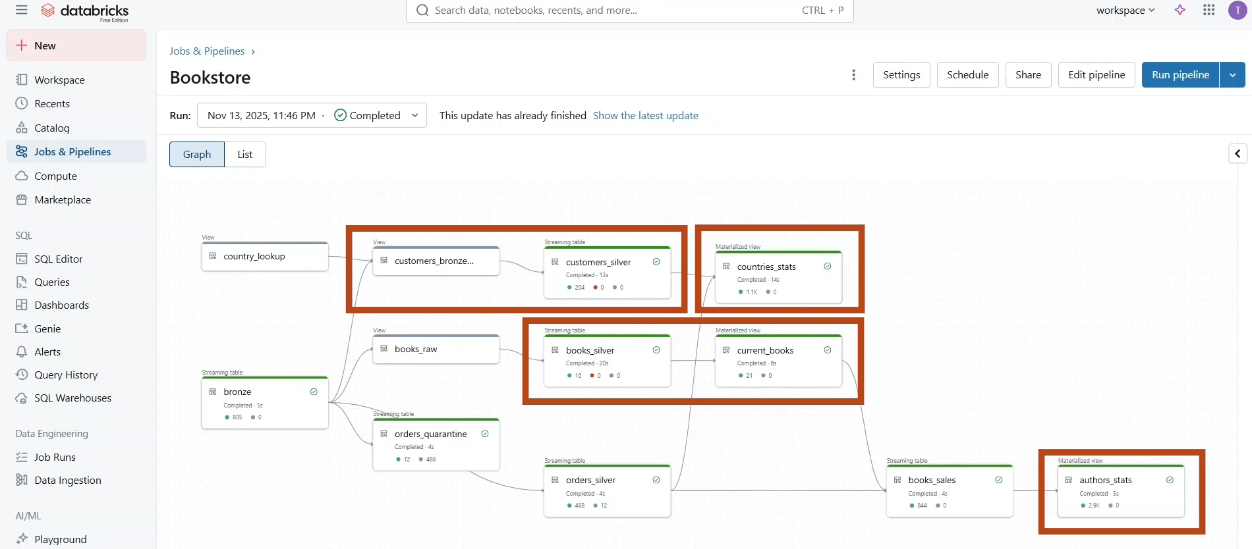

* For this, let us add a **new Python source file**. And **import the Pipelines and Functions modules**. In order to work with Auto CDC, we need first to define our source and target.
  + We define our source as a temporary view that handles the customer CDC data from the bronze table.
  + Here we also perform a broadcast join with a country lookup to retrieve the country name.
  + Next, we define our target table into which the changes from the CDC feed will be incrementally applied.

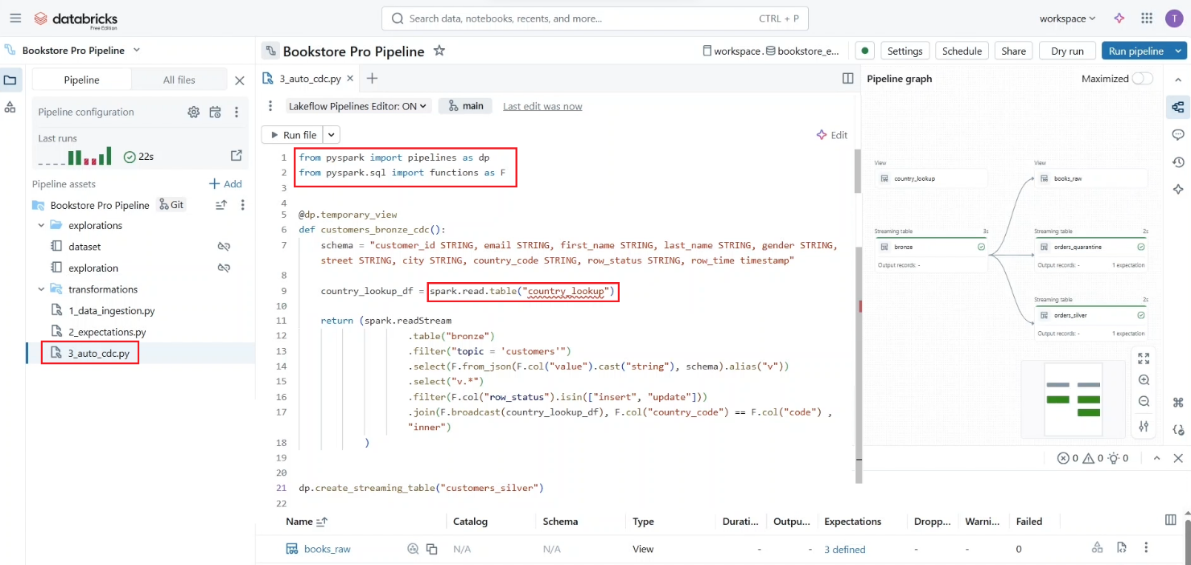

* + These should be declared in a separate statement using the **Create Streaming Table function**.
* Now we can proceed to use the Auto CDC function.
  + Here we start by specifying the table **customer silver** as the **target** table and the customer is **bronze CDC** as the source of our CDC feed.
  + Then we identify the **customer ID** as the **primary key**. If the key exists in the target table, the record will be updated. If not, it will be inserted.
  + Next, we specify the order time field for ordering the operations and handling out-of-sequence records.
  + Lastly, we indicate that all fields should be added to the target table except the operation columns – “**row_status**” and “**row_time**”.

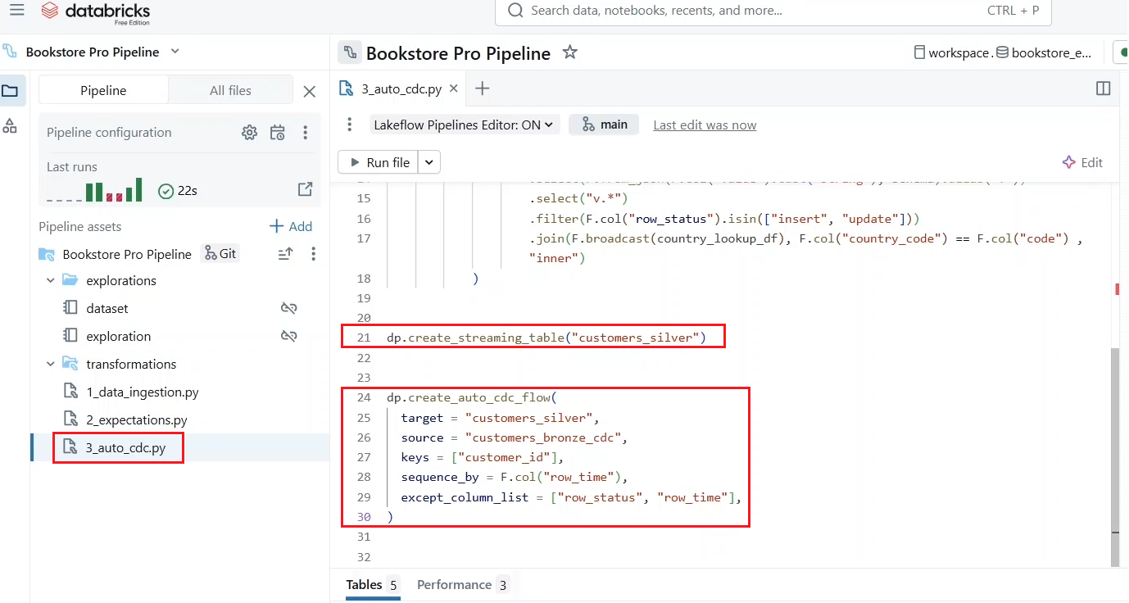

* + Remember, you can also specify that records with **row_status** is delete should be deleted from the target table. This is an optional clause as you may need a separate process to handle delete requests.

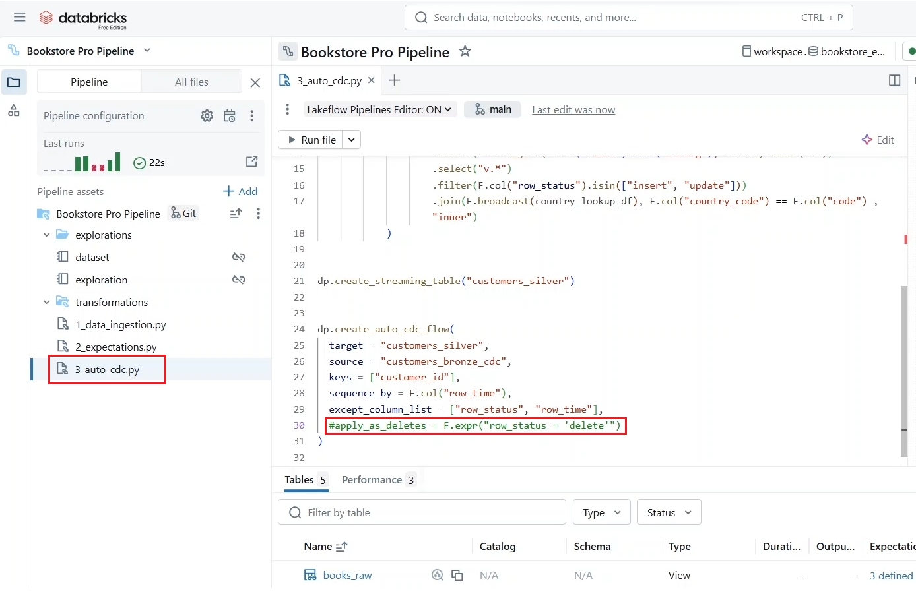

* Let us run the pipeline.
* Our source view and target table have been successfully created. And as you can see, there are **396 records** have been upserted into the “**customers_silver**” table.

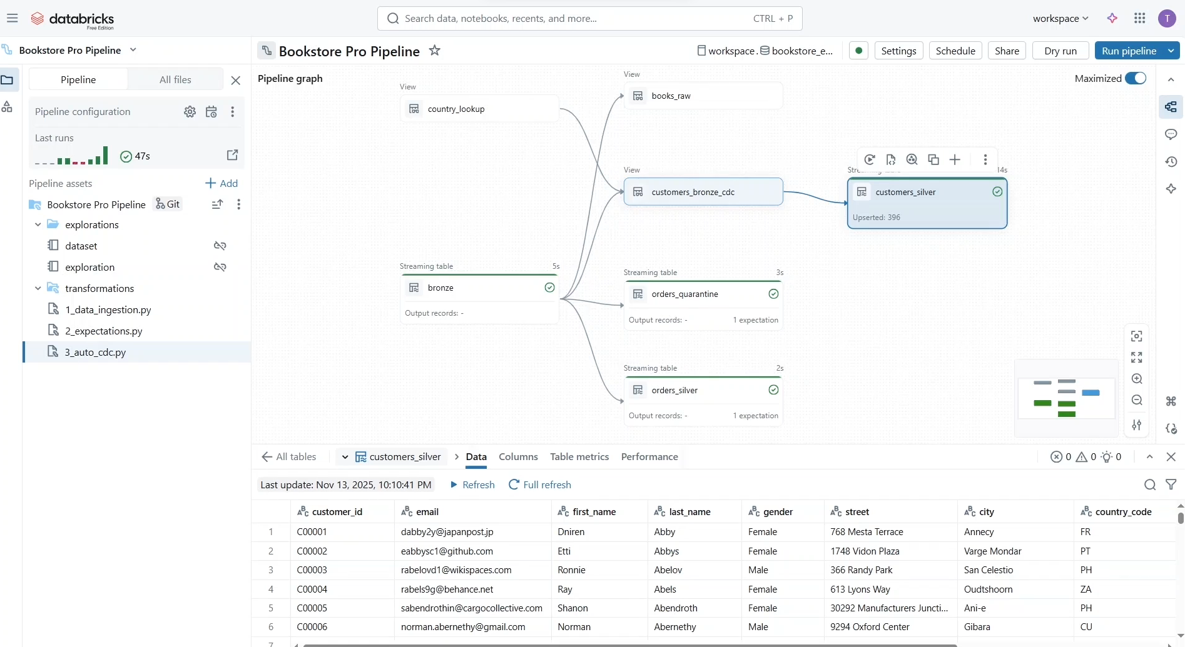

* Let us add a new batch of data and see how it will be processed by our pipeline.
* Notice that the previously created streaming tables, they didn’t process any data as there were no new data files ingested.

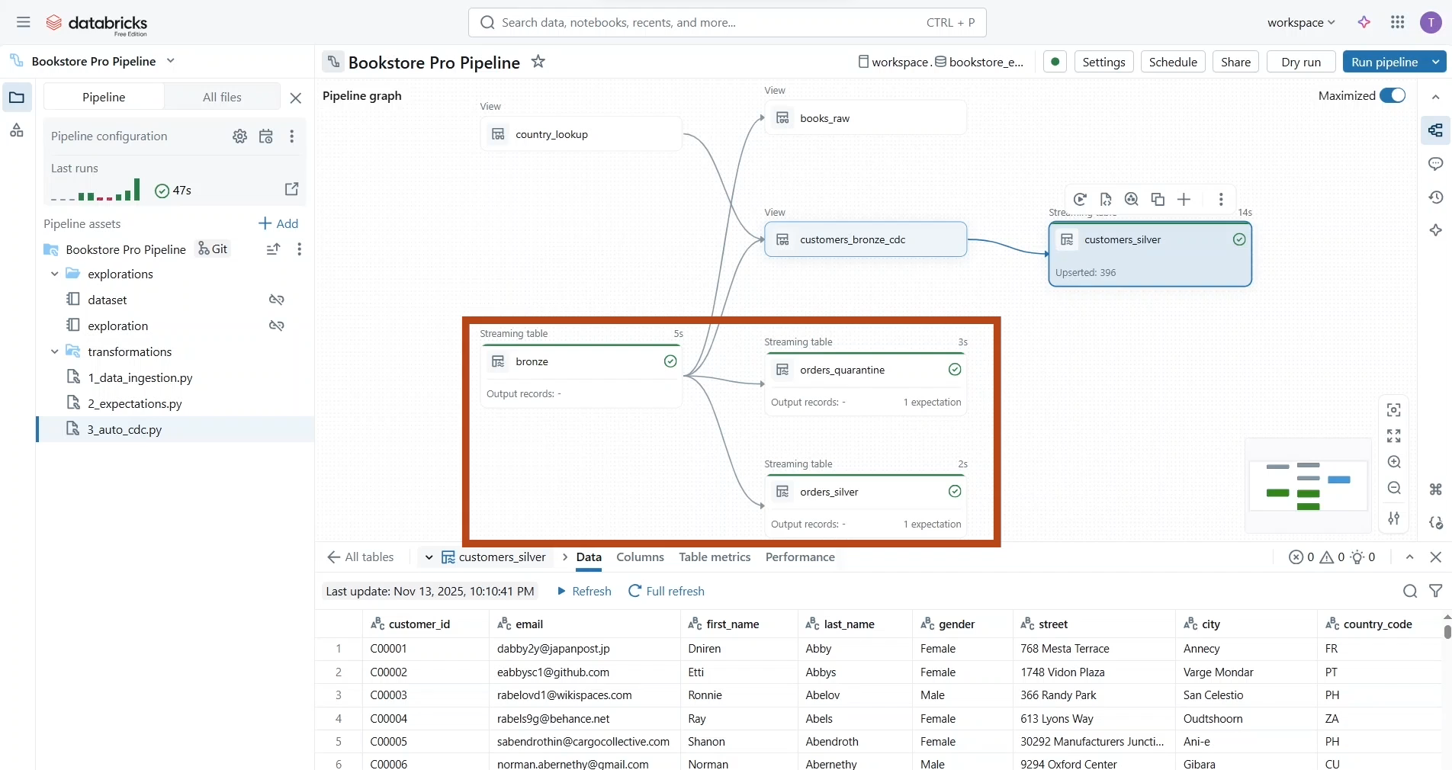

* To land new data files in our source directory, let us use the **dataset notebook**. Run the copy dataset notebook. And execute this helper function “**load_pipeline_data**”. Let us run the pipeline again to process this new data.

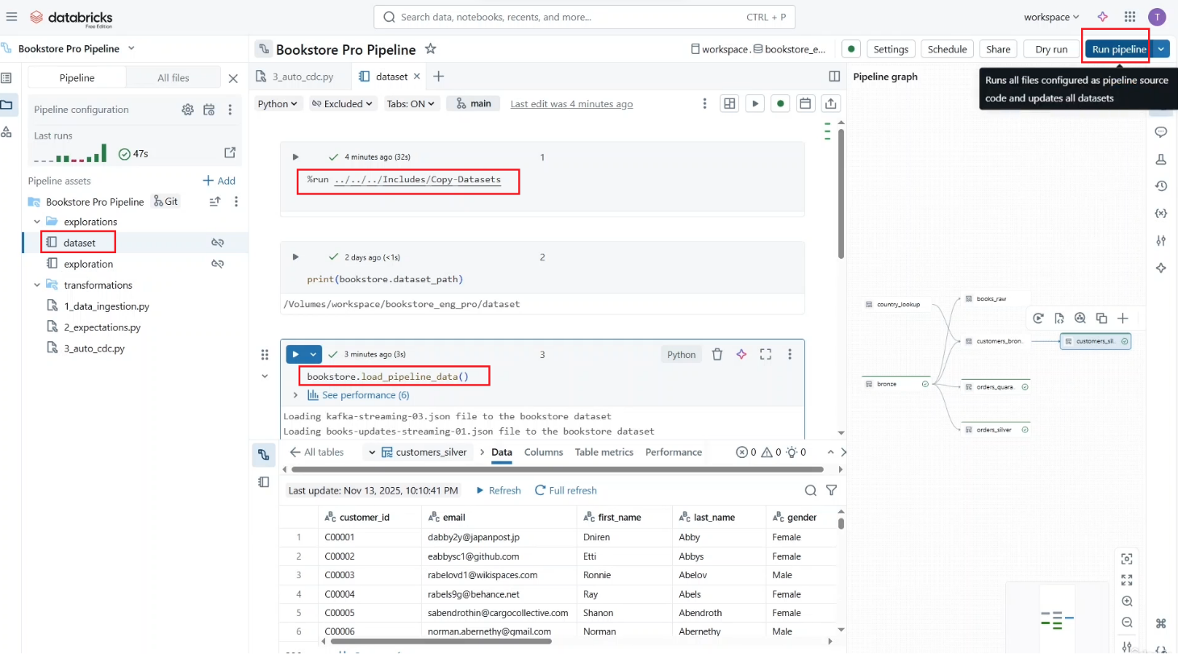

* As you can see, the bronze table has received more than 800 new records, and we have 488 new orders with the 12 invalid records isolated in the **quarantine table**.

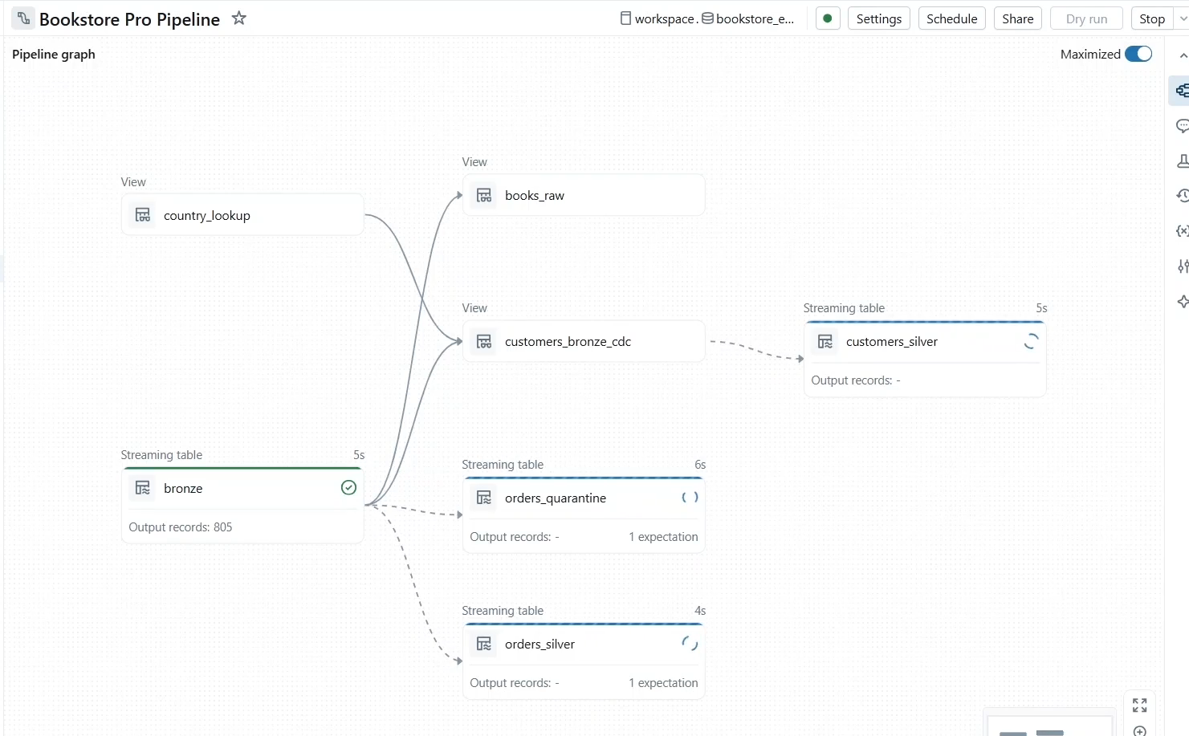

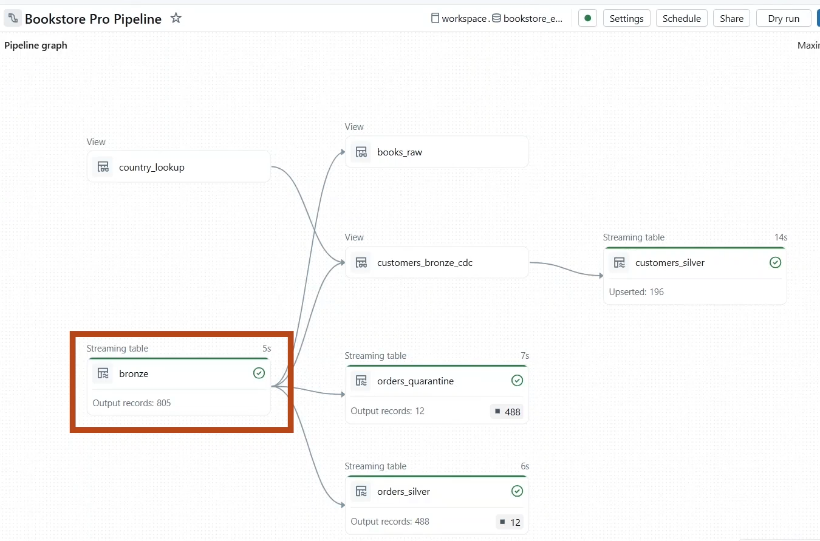

* In the customer table, we can see 196 CDC records asserted into the table. And of course, there are zero deleted records.

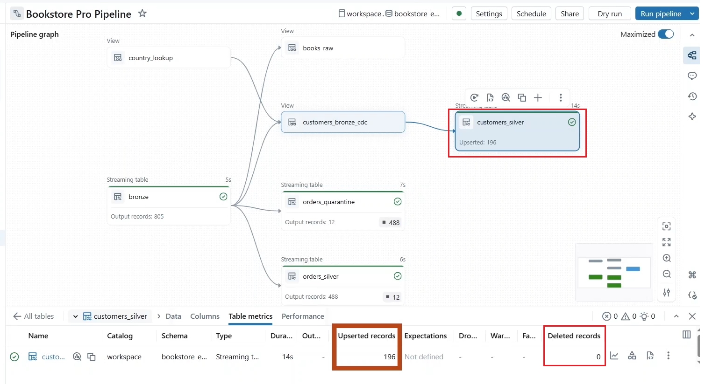

* So, under the data tab, we can see now that our table contains more than 500 records.

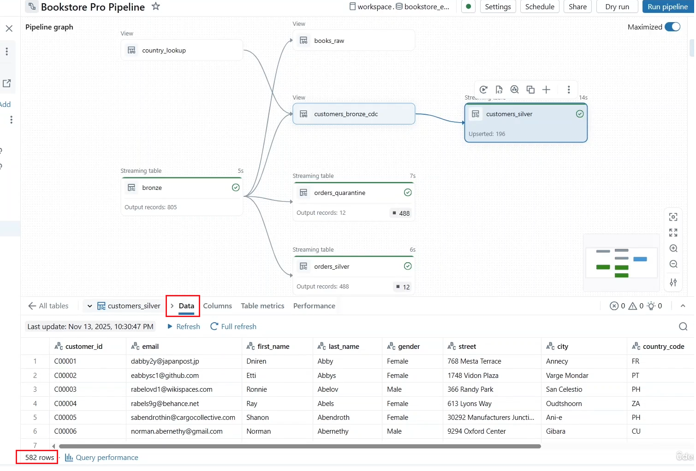

* Add the **gold layer**.
  + We create our countries statistic view as a materialized view.
  + This content joins between customers and orders, data and business level aggregations.
  + Precomputing the results and materializing them will help improve query performance and accelerate pie dashboard and reporting.
  + To create a materialized view. Simply, we use the materialized view decorator.
  + Notice that we've materialized views. We use spark to **read** method instead of **readStream** method.

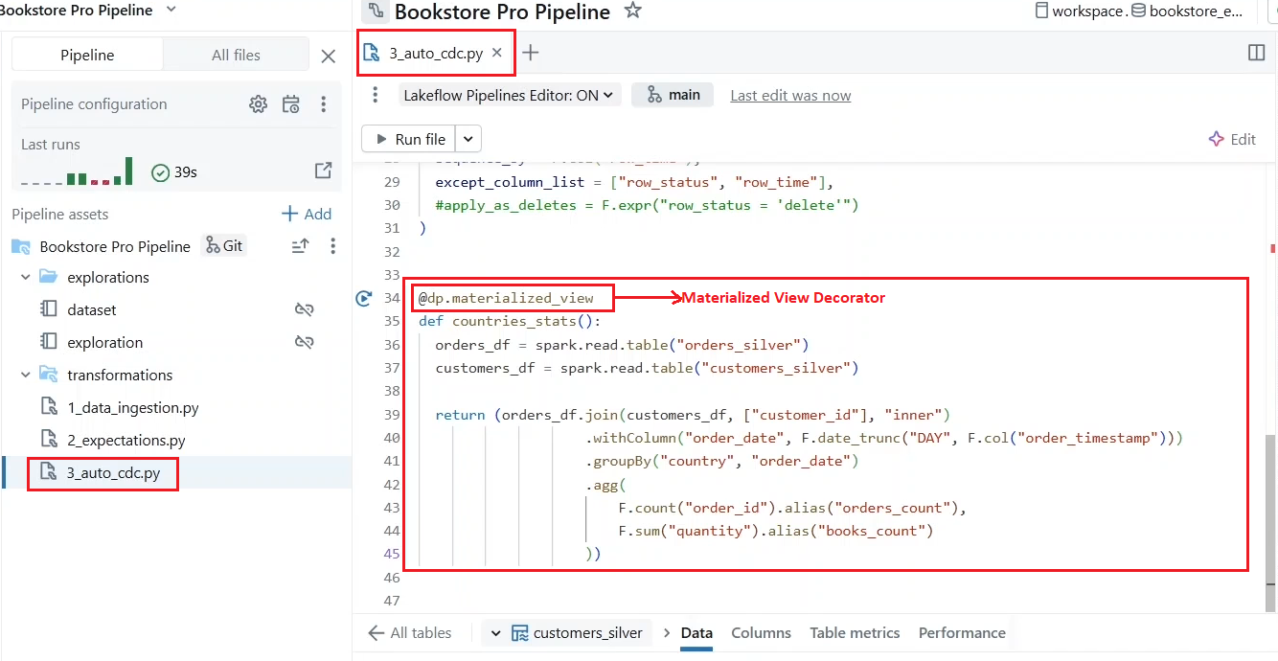

* Let us try to use read stream on the “**orders_silver**” table, which is an **append only** table and see what will happen. Let us run the pipeline.

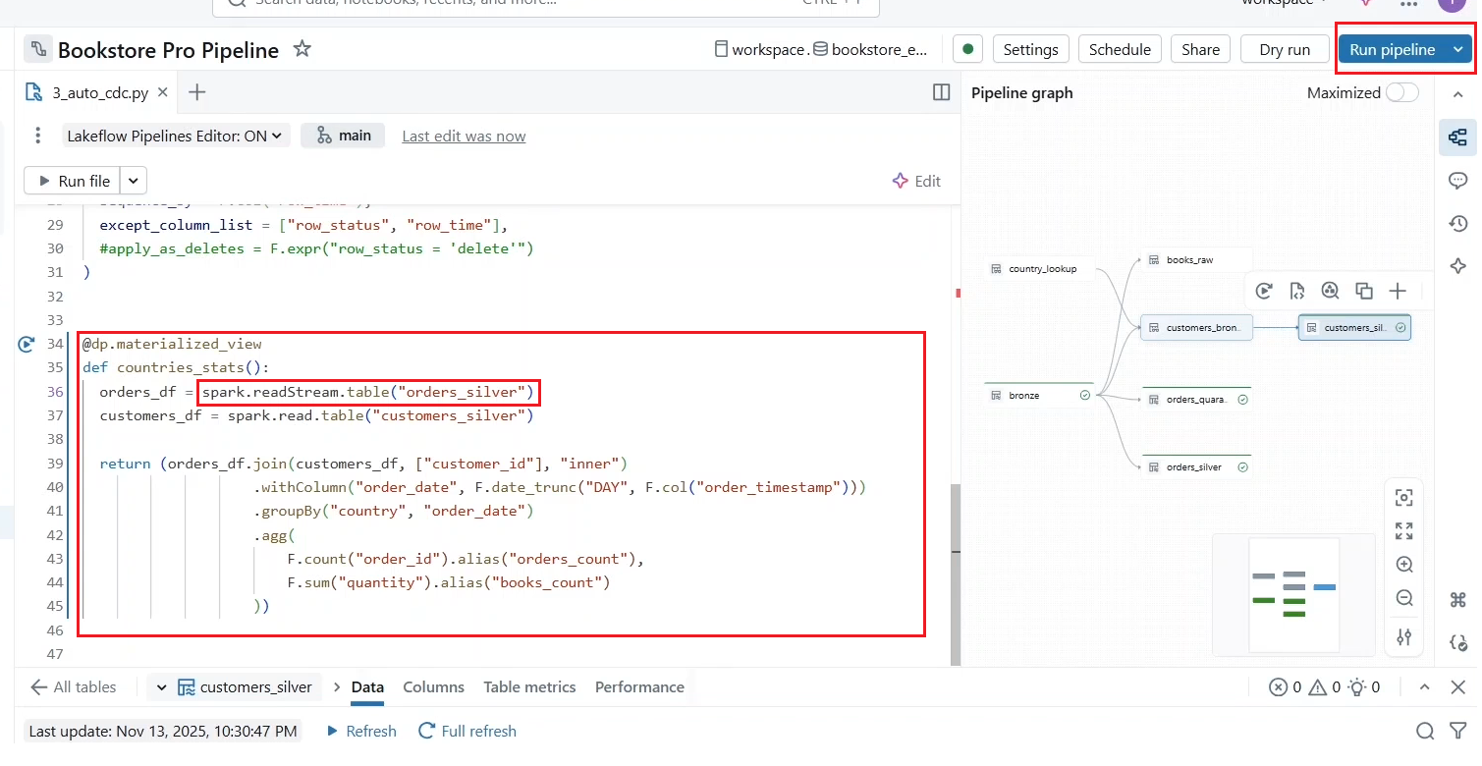

* + Notice that the “**customers_silver**” table is no longer valid for streaming, since it now contains data that have been updated by the Auto CDC flow.
  + As you can see, using **readStream** has generated an error as it returns a streaming data frame while a non-streaming data frame is expected for materialized views.
  + Click “**Jump to code**” to identify the object causing the error, which is in our case, the materialized view.

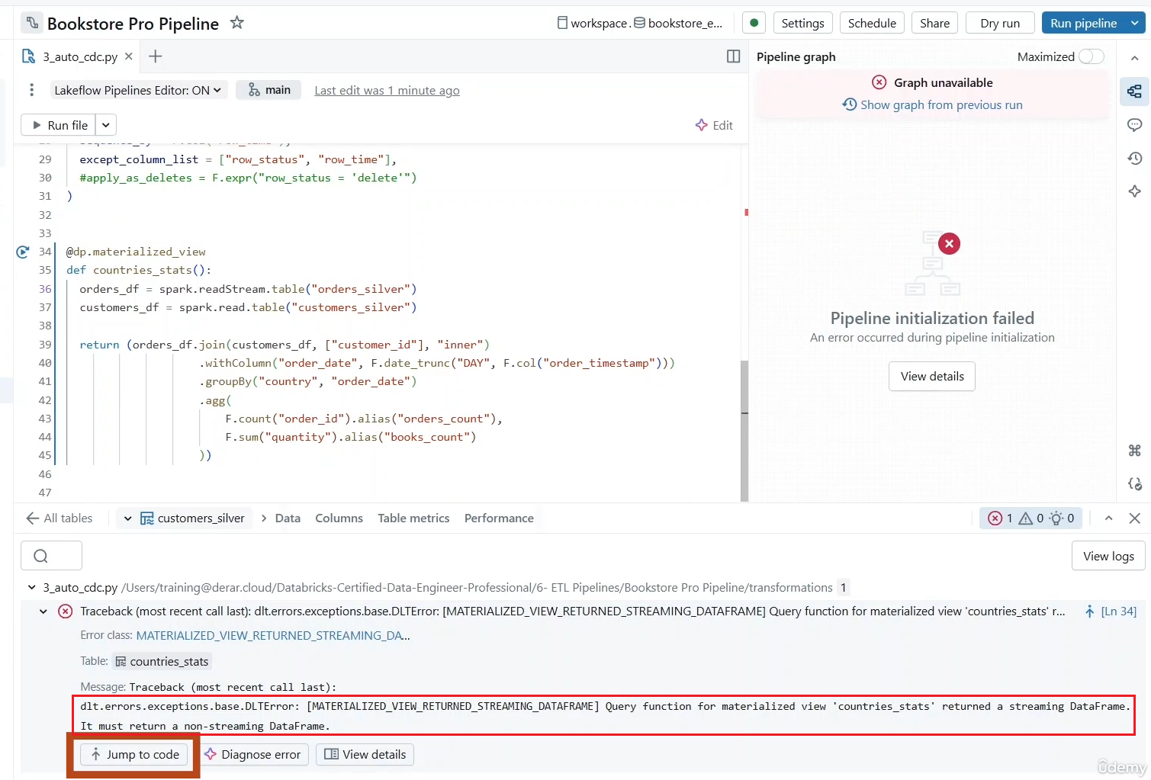

* + And let us use spark to use **read** method instead. Let us run the pipeline again. Our materialized view has been successfully created, and we can see the daily statistics per country.

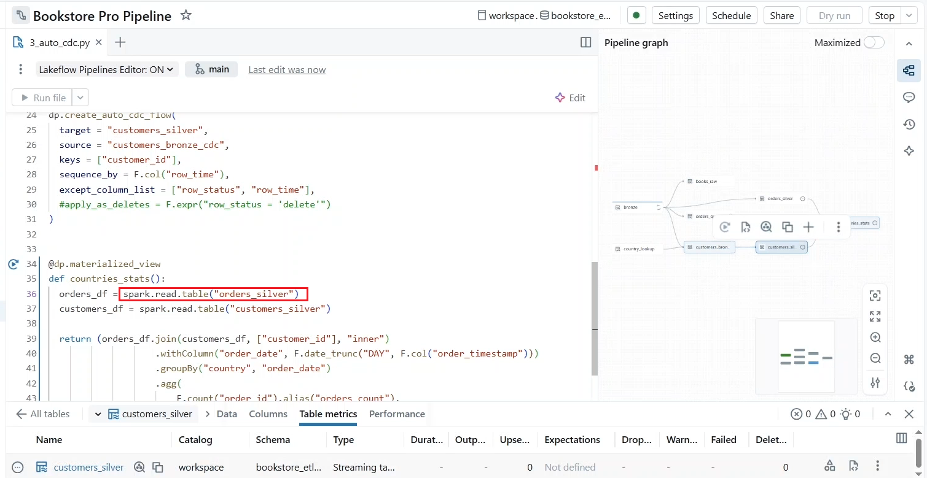

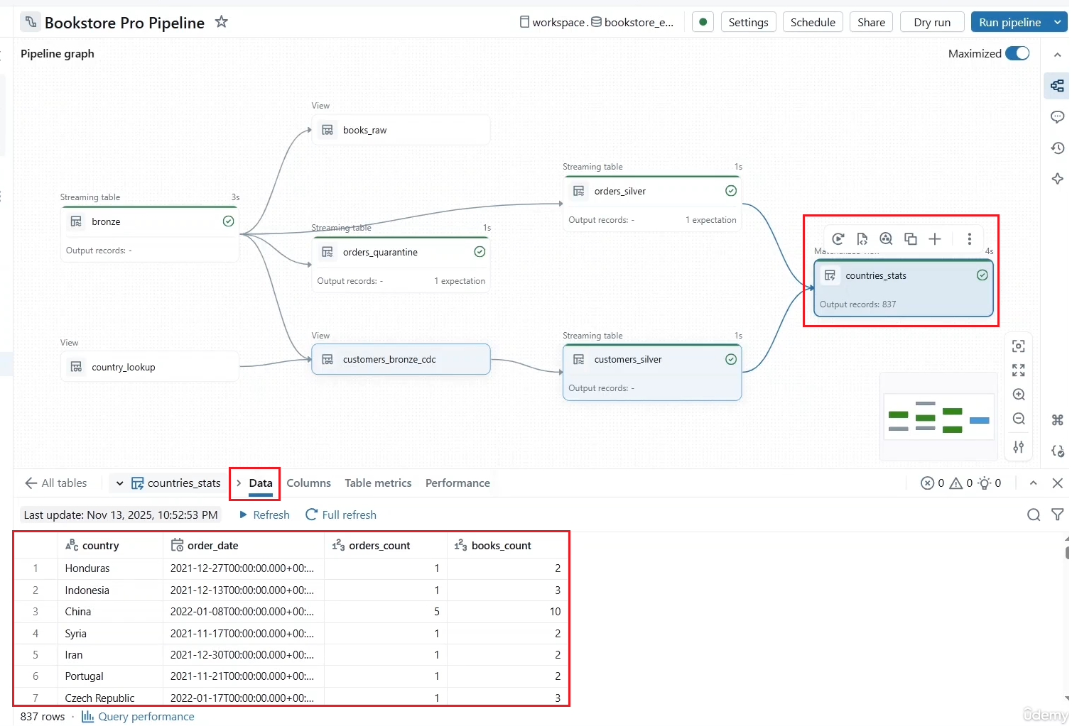

* Auto CDC supports updates using CDC type 1 and 2. By default, it uses SCD type one, so new data overrides old one. If you need to process SCD type 2 updates, you can simply add the parameter stored as SCD type equal 2.

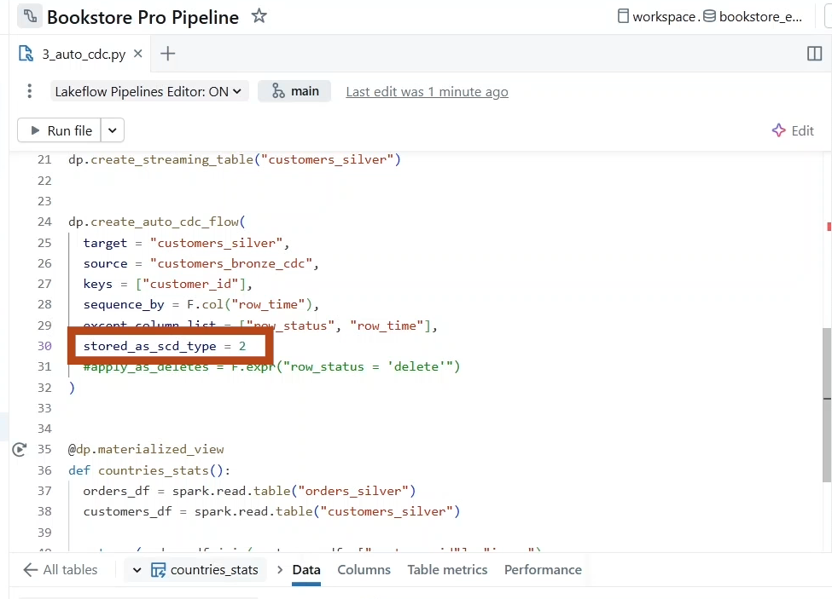

* Let us see an example on this, but this time in SQL. A great feature of Lake Flow declarative pipeline is that it allows you to use both Python and SQL in the same pipeline. Let us demonstrate this.
  + Start by creating a new source file, but this time in SQL.

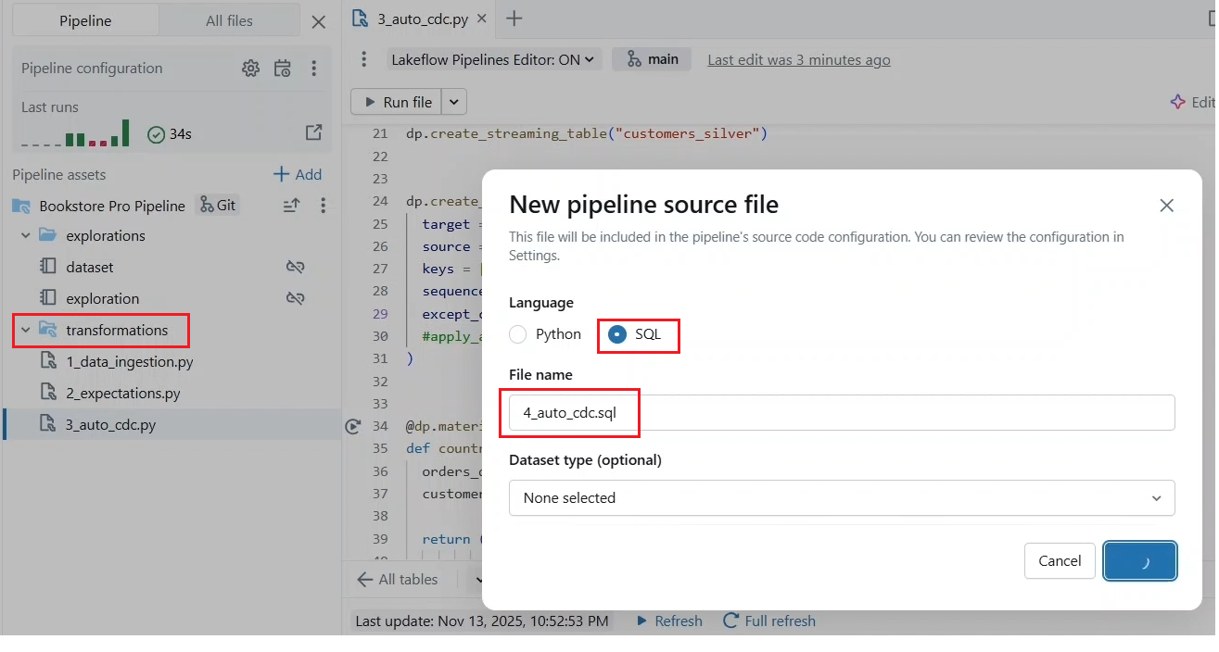

* + Let us process our books data as a CDC type 2 updates.
  + We start by declaring our target table in a separate statement.
  + Then we use Auto CDC by creating a flow to apply the updates into the target table. These updates are streamed from our source **Books** row, which is a temporary view we created last Lecture.
    - * Then we identify the **book_id** as the primary key. Again, if the key exists in the target table, the record will be updated. If not, it will be inserted, and we specify the updated timestamp field for ordering the operations.
      * After that, we indicate that all “books” fields should be added into the target table except the updated timestamp field, which will be replaced by two new timestamp fields start at and end at to track the history of records.
      * Lastly, we indicate that the updates should be stored as SCD type 2. This allows the table to return a history for updated records.
  + Let us run the pipeline.

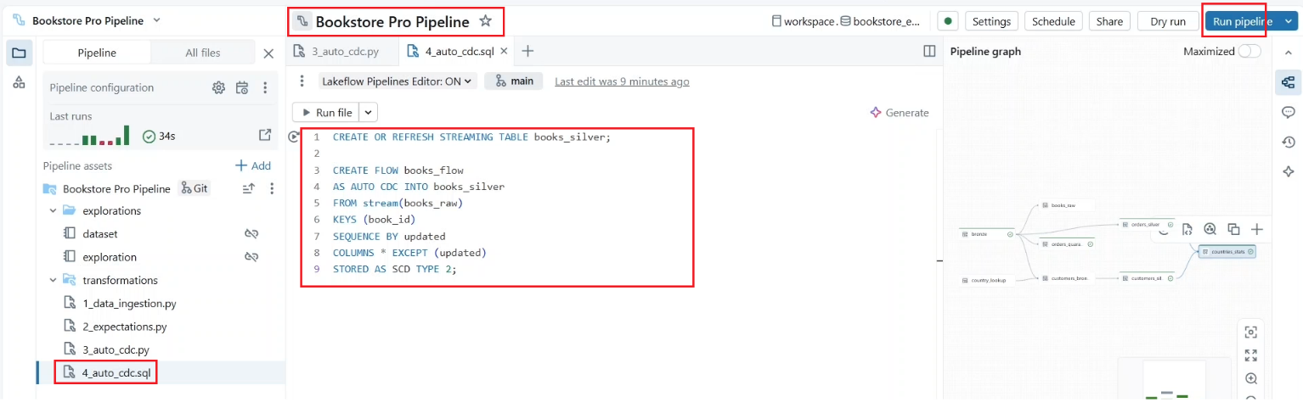

* Our “**books_silver**” table has been successfully created, and we can see that 26 records have been upserted into the table. And as you can see, two extra columns have been added to the table, which are **start_at** and **end_at** that are automatically managed to track the validity period of each record version. Notice that Auto CDC does not use the current Boolean flag. Simply records with NULL end date (i.e. _END_AT) represent the latest information.

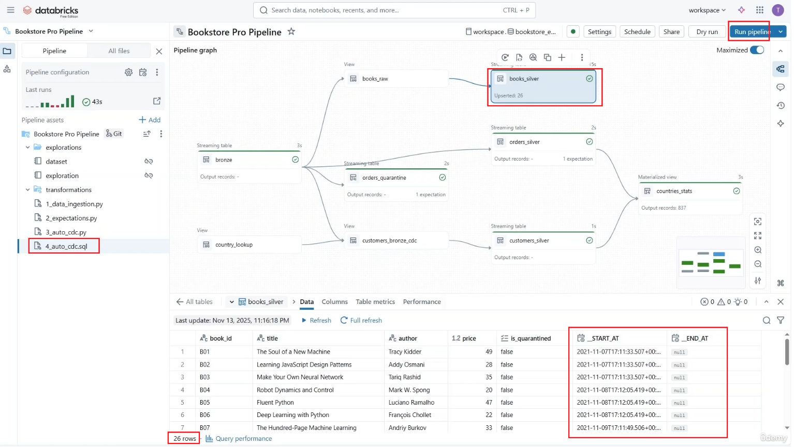

* Let us **create a materialized view** to store the latest (or current) book information based on this column.
  + We can achieve this in SQL using the Create or Refresh materialized view command.
  + Notice that this object cannot be a streaming table since it is source, the **books_silver** table is no longer streamable due to the updated data.

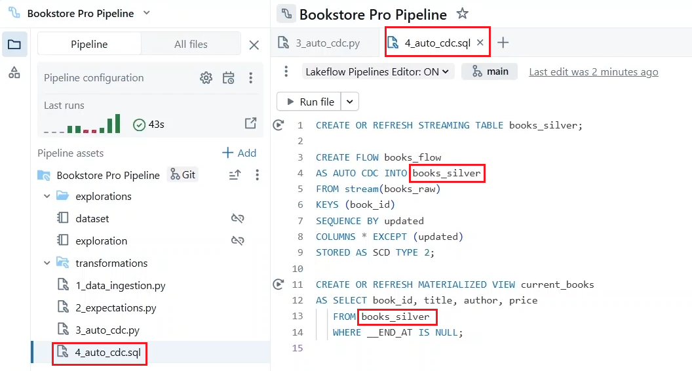

* Next create a streaming table **“books_sales**” using the Create or Refresh streaming table command. Remember, to create a streaming table, your data source must be an append only source.
  + We query the **orders_silver** table as a streaming source using the **STREAM** function, and we perform a stream static join with the **current_books** review.
  + Notice that we are also using the **constraint keyword to define data quality expectations** on this table using SQL syntax. So, we specify a logical condition that the data must satisfy using the **expect** function, and we control how violations are handled using the ON violation clause.
    - * ON VIOLATION DROP ROW, to discard invalid records and
      * ON VIOLATION FAIL UPDATE, to stop the pipeline execution if any invalid record is detected.
      * This ON VIOLATION clause is optional. If it is omitted, like in the 3rd constraint, this means this is just a warning. So invalid records are written to the table, **but they are still reported in metrics**.

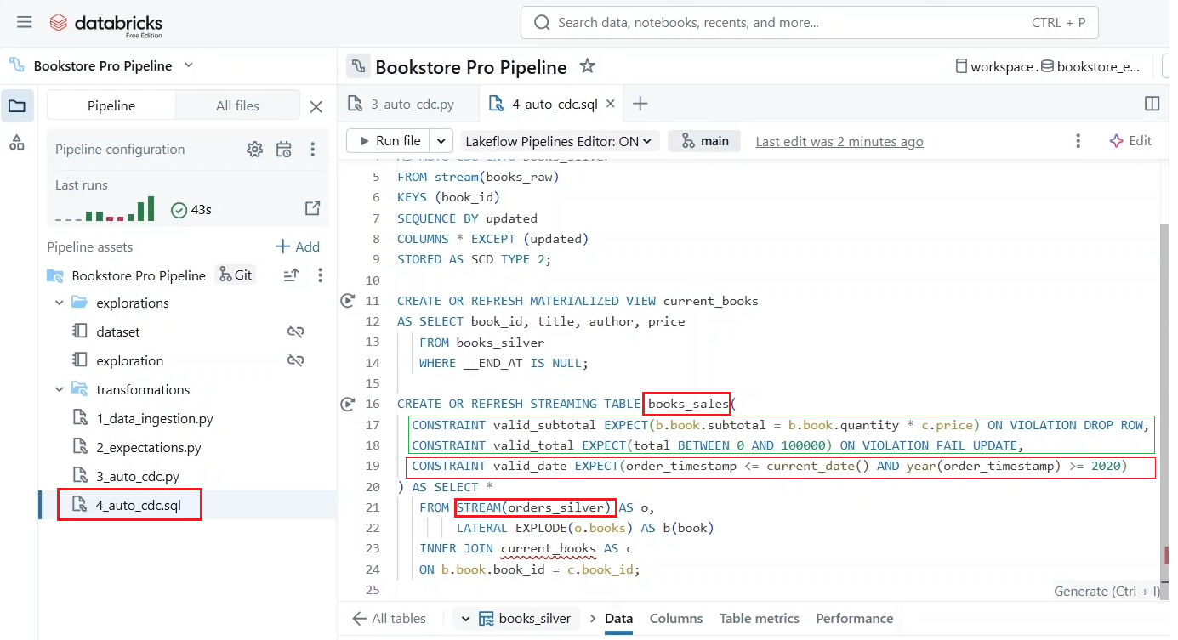

* **Lastly, at the gold layer**, we create a materialized view to calculate aggregated statistic of book sales per author in non-overlapping 5-minute windows.
  + Moreover, in this calculation, we need to shift all the windows by **2 minutes offset**. To achieve this, we group the data by **author** and apply a window function on the **order_timestamp**. The window here is defined with a **size of 5 minutes** and a slight **interval or step of 5 minutes**. This step indicates how often a new window starts. So, a step of 5 minutes produces **non-overlapping windows**. Finally, we set a starting offset of 2 minutes.

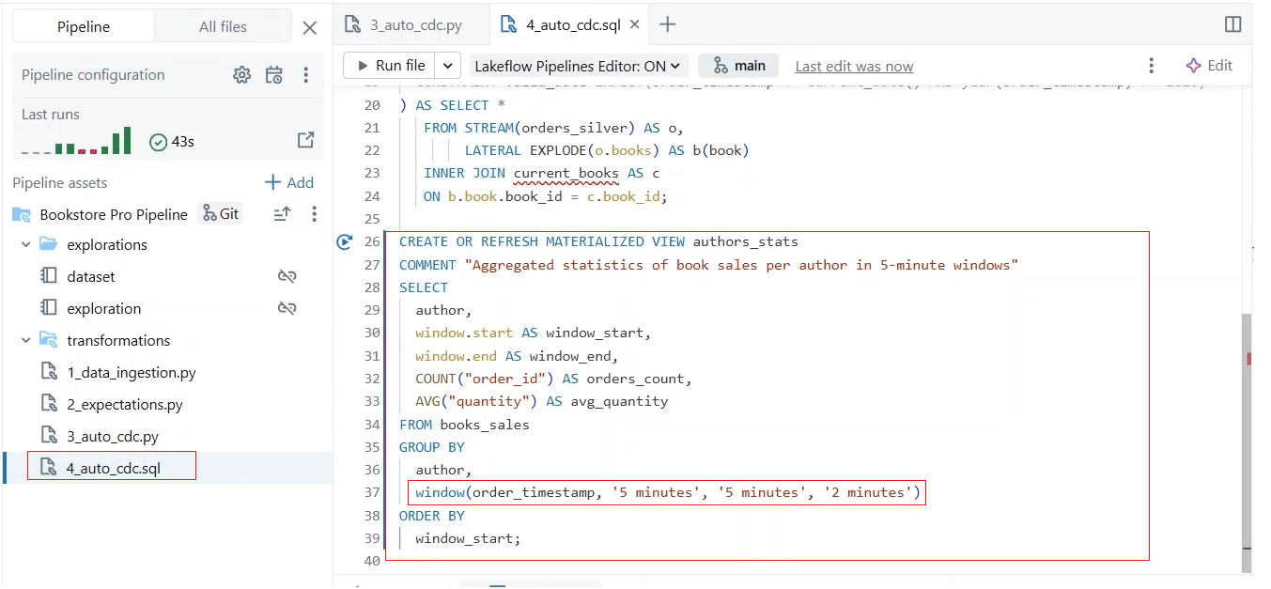

* + Let us run our pipeline now.
* Our objects have been successfully created.

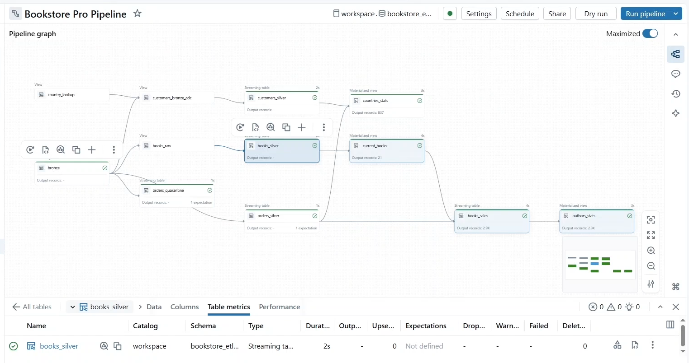

* And here are our author statistics (i.e. author_stats).
  + For example, for this author, we can see his statistic for a 5-minute interval with a 2-minute offset.
  + And we can see the next window starting at the end of the previous one confirming that the interval are non-overlapping.

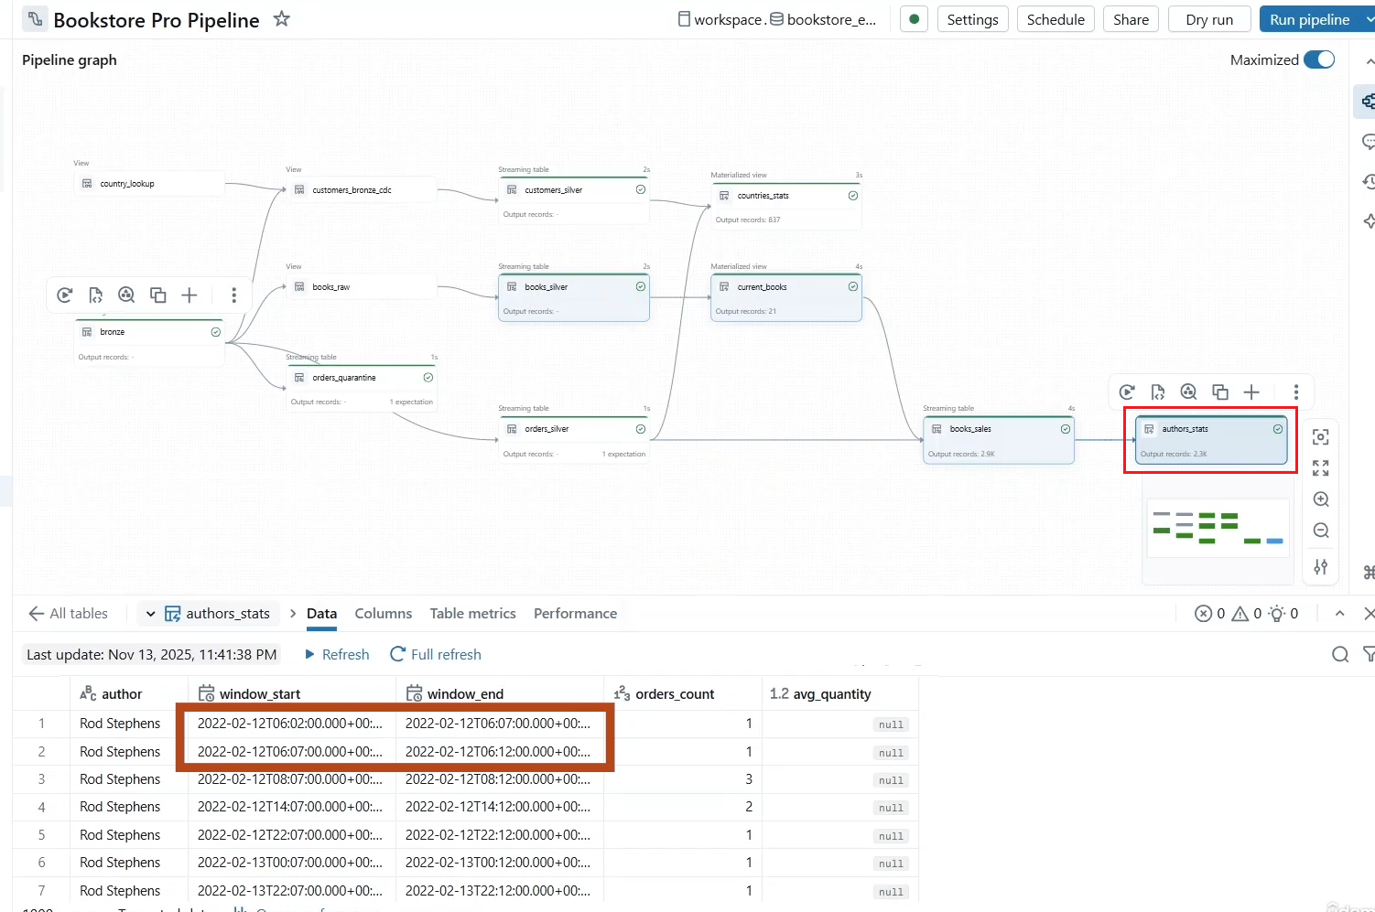

* Let us end up by landing a new batch of data and see how it will be processed through all the objects in our pipeline. 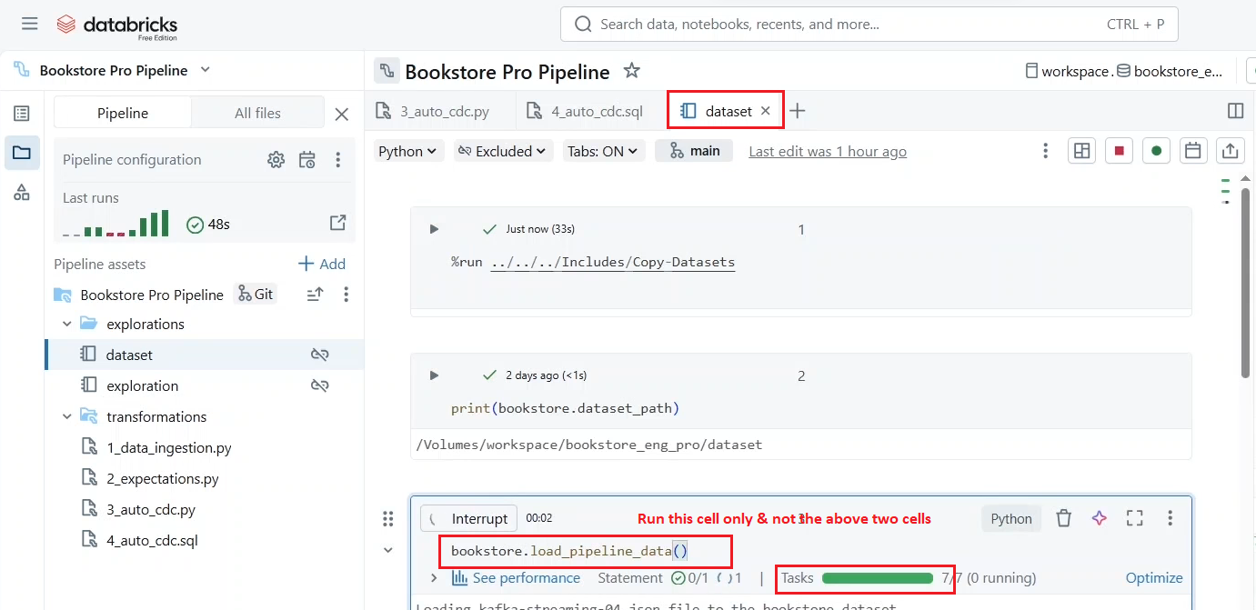
* **Let us run the pipeline again.**
  + As you can see in our SCD type 2 table (i.e. books_silver), there are keys like B16 with more than one record, but only one record book_id having a null end date (i.e. _END_DT) representing the latest information.

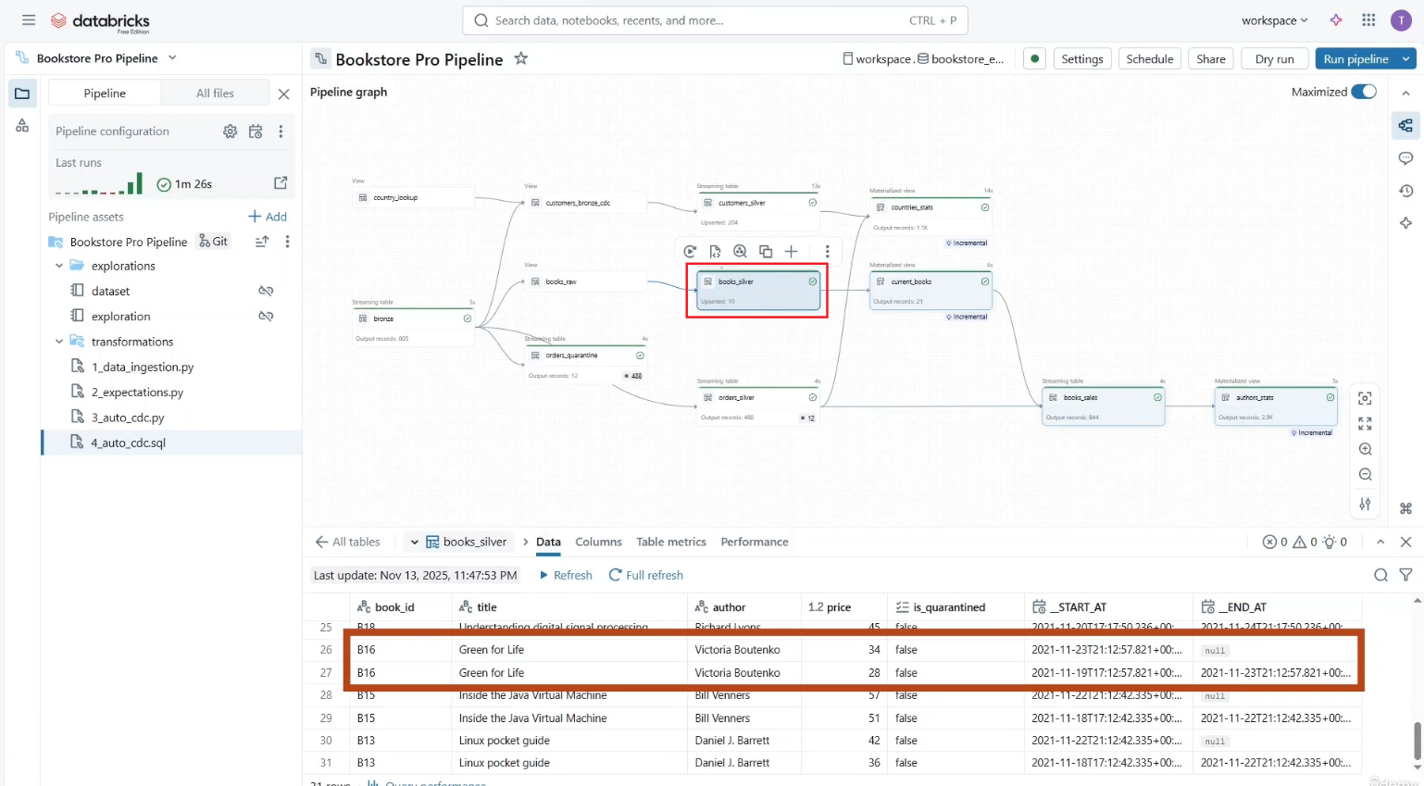

* In addition, notice here the hint that says **incremental** next to some **materialized views**. This indicates that the materialized view has been incrementally updated.
  + This is because our pipeline is connected to a serverless compute.
  + The default refresh for materialized view on serverless compute attempts to perform an incremental refresh instead of full refresh.
  + This means processing changes in the source data since the last pipeline run and then appending the data to the materialized view.
  + However, keep in mind that only certain types of materialized views can be incrementally refreshed depending on the source table and the complexity of the included operations.
  + If an incremental refresh is not possible or the pipeline is connected to a **classic compute**, then a full refresh is performed.

